Shabbos Stories For Parshas ki savo 5784

Volume 15, Issue 56 18 Elul 5784/September 21, 2024
Printed L’illuy nishmas Nechama bas R’ Noach, a”h
For a free subscription, please forward your request to keren18@juno.com
Past emails can be found on the website – ShabbosStories.com

Something from Nothing



There were two tailors, Meir and Shmuel (names changed), who traveled from village to village in Eastern Europe, offering their services to the villagers, saving a few kopeks here and there until they’d have enough to return home. When they finally collected enough to go home, the traveling tailors stayed at the inn of a Jew who, as a side job, managed the properties of the local landlord.
They noticed that the innkeeper seemed very distraught, and so the two tailors insisted he confide with them his predicament.
“The non-Jewish landlord received some fine cloth as a gift from a prince,” he explained. “He got it in his head that the cloth must be made into the finest royal-looking garb, but no tailor I bring him is adequate. And now he’s threatening me that if I do not find him a first-class, Parisian-style tailor who can alter it to his outrageous standards, he’s going to throw me and my family into the dungeon!”

The Tailors Offer to Help the Innkeeper
Though they yearned to see their families and children, Meir and Shmuel were eager to help a fellow Jew. “We are fine expert tailors,” they insisted. “We can do the job!”
Reluctantly, the innkeeper agreed. “What do I have to lose?” he said. “There’s no alternative.”
Miraculously, the landlord handed them the precious material. Within two weeks, they stood before him with the finest robe. Everybody was then happy: the landlord was on cloud nine with his new garment; the innkeeper was very relieved to hear that the landlord was happy; and Meir and Shmuel were happy with an extra thirty rubles each for the job they completed.
Now, the landlord’s wife was also in attendance as her husband gladly paid Meir and Shmuel for their work. She figured that she knew why these two Jews were really happy: they had saved their fellow Jew and his family from the dungeon. With that thought, she turned to her husband and said, “Tell them about the family in the dungeon. Maybe they will pay the ransom.”

The Jewish Family that Needed to be Ransomed
That’s the way they did things in those days: if a family couldn’t pay their rent, the landlord put them into the dungeon until it was paid. Ingenious, right? So, the landlord told them about the Jewish family he’d thrown into the dungeon that was waiting to be ransomed.
“How much do they owe?” they asked.
“Forty rubles.”
“Sure,” said Meir. “We can put that together to save a family from the dungeon, can’t we, Shmuel?”
Shmuel wasn’t as quick to agree as Meir, though. His share of the forty rubles would be a considerable portion of his savings. He had been traveling almost a year without seeing his family. So, while it was certainly sad that this family in the dungeon was suffering, he couldn’t come to simply part with all that money on their account.
Meir saw that Shmuel wasn’t willing to put up money, he counted out his entire savings, asked Shmuel for just a few more rubles, and came up with exactly forty rubles for the family’s release. Next thing he knew, the family was released from the dungeon, pale and sickly, kissing and hugging his feet for saving their lives.
Then Meir and Shmuel returned home. Shmuel’s family was happy to see him. He used the money he earned to set up a tailor shop, and since he had merchandise to start out with, he soon became very successful.
Meir’s family, on the other hand, was certainly disappointed. He didn’t want to tell them how he used all his savings. It was a mitzvah, after all, and you don’t brag about mitzvos. And besides, they wouldn’t understand. So, they thought what they thought, and the family sank deeper into poverty. Slowly, Meir started to sink into a depression. He sank deeper and deeper until he could do nothing but stand at a street corner, his open hand stretched out for alms.

Standing in the Heat of Summer,
the Rain, Freezing Wind and Snow
He stood there through the heat of summer, the autumn rain, and the freezing wind and snow of winter, a hollow and forlorn soul. Whoever dropped a coin in his hand received a brachah, but beyond that, he didn’t speak a word to anyone. No one. He believed he was nothing, a nobody.
Then, one day, a merchant walked briskly by Meir, late for an important business meeting. He dropped a coin in Meir’s hand as he marched by, barely hearing Meir’s brachah as he passed. “May Hashem bentch you in all you do,” said Meir. And He did. The business worked out better than imagined. Maybe, he thought, it had something to do with that beggar’s brachah. So, the next time the merchant had a deal to make, he made sure to pass Meir the beggar and hand him a coin. And that time, he waited to hear the brachah and answer “Amen.” And once again, the brachah had a miraculous effect.
As you can imagine, this became the merchant’s regular practice. Rapidly, he became one of the wealthiest merchants in the district. Knowing that whatever he touched made profit, everyone wanted to partner with him. The merchant bought a new mansion for his family and held a grand party at which he got rather drunk. That’s when he spilled the beans.

Reveals the Secret of His Incredible Success
“You think I’m rich because I’m smart?” he confided. “Or because of my good deeds? It’s none of the above! It’s all due to the brachah of a ragged beggar who stands motionless at the corner on the way to the market!”
The next morning, there was a line waiting for Meir to arrive at his normal spot. People gave, Meir benched, and miracles happened. Meir was oblivious to it all, so lost was he in his depression. Yet, his fame spread quickly. Soon, barren women were blessed with children, the sick were healed, and the biggest shlemazels actually got jobs—all as a consequence of Meir’s brachos.
That’s when the Baal Shem Tov came into the story. He also heard about this beggar-tzaddik whose brachos were as effective as the spring rains bringing seed to sprout. He traveled himself to Meir to see him firsthand. And he took Meir aside and said, “Now tell me your story.” The Baal Shem Tov was that way. He could converse with anybody, and that person would open up as though he was his closest friend.
Meir told him the story of his life. But the story of the forty rubles came hard. “You must tell,” said the Baal Shem Tov. “You must remember and tell.” And when he did, the Baal Shem Tov hugged and kissed him. He took him back to his town of Medzhibuzh, to his study hall, and made him one of his closest students. Meir studied Talmud and Kabbalah, and became a master of the secret lore. He became a tzaddik. He became a real somebody.
Many of us may feel like nobodies. That’s OK. The moon must disappear before it becomes full again. The seed must rot before it becomes a great oak. But that isn’t everlasting. The light one day will shine. There are better and brighter days waiting. There’s a light at the end of the tunnel. Knowing that Hashem is running a perfect world gives us the serenity and confidence that there’s something good waiting us.

Reprinted from the Parshas Eikev 5784 email of Zichru Toras Moshe.
The Powerful Rebuke
By Rabbi David Ashear

Rafi* always claimed that he wanted to get married but “things never worked out” for him. After he turned forty, his family and friends began to despair. Despite their best efforts to introduce him to eligible women and talk some sense into him, he remained unattached. There was nothing left for them to say to convince him to settle down.
But, as always, Hashem’s yeshuah can come in the blink of an eye. Rafi traveled out of state with his associates to participate in a series of meetings over the course of two days. Toward the end of the negotiations, David,* the businessman they had gone to meet, said to Rafi, “I want to ask you a question. Why aren’t you married yet?”
Rafi was taken aback by the sudden, very personal inquiry. He stammered a vague reply. “Things just never worked out.”
David would not give up. “What are you looking for in a wife?”
Rafi mentioned several qualities he hoped to find.
“Do you mean to tell me that you never met a woman in the past twenty years with those qualities?” Jack asked incredulously.
“Well, actually, I did, about five years ago,” Rafi admitted, “but it didn’t work out.” Rafi tried to change the subject, but David would not let him off the hook.
“Do you mean to tell me there’s a girl out there that matches what you’re looking for and you’re still not married? You’d better go find her and stop wasting time!” They concluded the business deal and Rafi and his associates traveled back to their hometown.
Rafi could not get David’s words out of his head. Everything he said was so obvious, but it had never clicked in Rafi’s brain before. He made some inquiries and discovered that the girl was still single. Two months later, they were engaged. Rafi’s family and friends were in awe of the sudden turn of events. The same words they had been saying for years did not do anything, but a few words from a random individual changed everything. (Excerpted from the ArtScroll book –“Living Emunah on Shidduchim”)

Reprinted from the Parshas Eikev 5784 email of The Weekly Vort.

A Miracle in Southern Tel Aviv

Rav Avraham Meshulam, the Gabbai of the Rashbi shul in southern Tel Aviv, where a great neis occurred on Sunday evening when a suicide bomber’s powerful bomb prematurely exploded ten meters away from it, spoke to the media on Monday about the magnitude of the neis.
“The explosion was louder than I’ve ever heard before,” he said. “The whole shul shook like in a powerful earthquake. The electricity went out in part of the building and the glass of the windows shattered on people. Miraculously there were no people on the street at the time except for one passerby who was injured and we daven for his speedy recovery.”

The True Story Caught on the Security Camera
“They saw on the security cameras that the terrorist had already approached the entrance of the shul, checked out the area and saw that there was a shul there full of people. Afterward, you see him going back ten meters and sitting on a bench and fiddling with the buttons inside his knapsack. Hakadosh Baruch Hu caused him to make a mistake and apparently, he accidentally pressed the wrong button, activating the device at that moment and not several minutes afterward. It truly was a nes - miracle.
The building next to the shul, a hardware store, was destroyed – the wall completely exploded. The glass that shattered on us was really marginal, nothing. None of us were hurt, not even a little. We believe that Hakadosh Baruch Hu protects us and saved us.”
Rav Meshulam told B’Chadrei Chareidim that the shul has a Yeshivas Bein Hazemanim every day, the largest one in the city, and the shul is especially crowded at night with mispallelim and lomdei Torah – exactly the time that the device exploded.

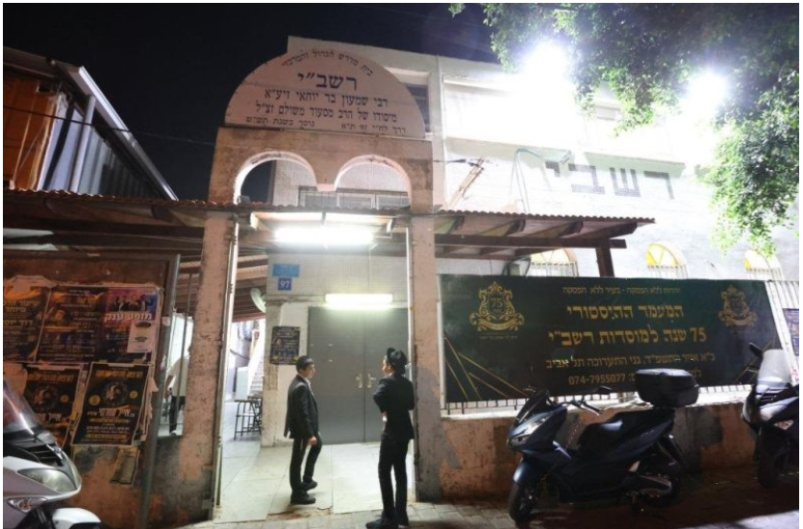
Photo of the Rashbi Shul in Tel Aviv.

“Just last week, the Sephardi Rav of Bnei Brak, HaGaon HaRav Masoud Ben-Shimon, came to the opening ceremony for Yeshivas Bein HaZemanim, and said: ‘Know one thing – this Yeshivas Bein HaZemanim protects all of Tel Aviv.’
“At that time, people didn’t attribute much importance to his words and thought it was simply a statement of chizzuk. But Baruch Hashem, everyone understands the koach of Torah – that’s what protects Am Yisrael. It could have ended in a mass-casualty incident – the explosion was extremely powerful.”

Reprinted from the Parashat Ekev 5784 email of Rabbi David Bibi’s Shabbat Shalom from Cyberspace.

A Heart-Warming Story
By Rabbi Yechiel Spero

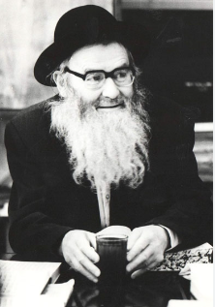

During his tenure as one of the premier leaders of Russian Jewry, R’ Yitzchak Zilber taught countless Jews who otherwise would have been completely ignorant of all Torah. Even after he made his way to Eress Yisrael, he would still make it his business to sneak back into his native country to inspire and instruct. During those trips, he had to make sure to keep a low profile because if his true identity were revealed he risked being sent to the Russian gulag, a prison from which few return.
Once, as he was on one of his trips, a man called out to him, “Reb Yitzchak! Reb Yitzchak!” Shocked that someone would call his name publicly, he turned around and recognized a man whom he had taught many years before, obviously in dire straits, dressed in rags. Poor and hungry and cold as he was, the man could not control his excitement upon seeing R’ Yitzchak for the first time in many years.
R’ Yitzchak tried to temper his own excitement in seeing the man, and after quickly looking around to make sure no one was watching, he asked many questions about how his former student was doing. Nothing, though, could have prepared him for the question this poor, hungry man asked him. “Rebbi, seven years ago I bought a new coat to wear during the winter months. I have not worn it yet. I was wondering if you would be able to check it for sha’atnez.”
R’ Yitzchak could hardly believe his ears…or his eyes. He looked at the coat the man was wearing. It was literally falling off his shoulders, it was so worn down. The man had purchased a coat seven years ago. Despite the brutal Russian winters, he was worried about the possibility that the new coat might contain sha’atnez and therefore had not worn it. Any Rabbi would have given him a heter (allowance) to wear the coat, regardless of whether or not it had sha’atnez; it was pikuach nefesh (saving a life); without the coat the man could have frozen to death. But to this unbelievably sincere Jew, sha’atnez was poison! He had probably been hoping, for the past seven years as his old coat became more and more tattered, that he would find someone able to check the coat for sha’atnez. It boggles the mind!
And now we can ask ourselves, and dig deep to find the answer:
What would we have done?

Reprinted from the ArtScroll book – “Touched by a Story 2” by Rabbi Yechiel Spero.

The One-Minute Letter

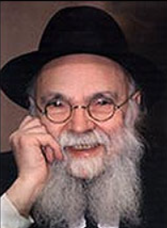

Rav Avraham Pam, zt”l, was known to use his words to make others feel good. He used to Daven next to an elderly neighbor in Shul who once got sick and had to be in the hospital. Rav Pam wanted very much to visit him and perform the Mitzvah of Bikur Cholim, but he was a Kohein, and he was not allowed to enter the hospital because of the concern that he might become Tamei.
He decided that instead of visiting, he would write a short note to his friend, wishing him well and give him a Brachah for a Refuah Sheleimah. It took only a minute or so to write. Rav Pam also mentioned in his letter that he hoped the man would return quickly to Shul so that they could Daven next to each other again.
The sick man was so very happy to receive this letter. It really encouraged him and helped him feel better. He kept it under his pillow and showed it to anyone who came to visit him, and said, “This is a letter I got from Rav Pam!” The letter became a treasure to him, and he said it was even better than a visit because he got to keep it.
The man eventually unfortunately passed away and when Rav Pam went to be Menacheim Avel, the family stood up for him and explained that the note he wrote made their father so happy.
Rav Pam later explained that such a small act, like writing a quick little note, had an impact that lasted for a long time after! He said we see how little it takes to make someone feel good, and it can also be done in such a short amount of time!

Reprinted from the Parshas Re’eh 5784 email of Rabbi Yehuda Winzelberg’s Torah U’Tefillah.
Why the Boy Can’t
See His Father

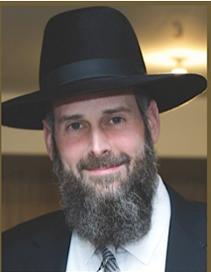

Rav Yosef Viener, Shlit”a, was once on a plane that was almost ready to take off when a young child came on and sat down in the empty seat next to him. The boy seemed to be traveling alone and looked very relaxed and calm about it, not anxious to be alone on a plane.
Feeling a slight responsibility to look after him, Rabbi Viener asked the boy if anyone was with him. The boy simply answered, “My father is here, but you can’t see him.”
Not knowing what he had gotten himself into and thinking the worst, Rabbi Viener began to look around at the other passengers to see if he could see someone that might be this boy’s father.
The boy explained, “The reason you can’t see him is because my father is the pilot, and he’s the one who is flying the plane.”
Rabbi Viener sat back and reflected how this young child was too little to realize how powerful the words that he had just spoken were. Life is sometimes just like that, where we feel like we are on a plane, and sense that things are spinning out of control. We conclude that there must be no one flying the plane because things are in such disarray.
But, when we realize that our Father is here but we can’t see Him because He is the Pilot, we can just sit back and relax because Hashem has everything under control. When we understand that Hashem, our Father, is “flying the plane”, we will also be able to sit and be calm, without anxiety, and without feeling that we are ever alone!

Reprinted from the Parshas Re’eh 5784 email of Rabbi Yehuda Winzelberg’s Torah U’Tefillah.
Covered Your Bill
By Rabbi Meyer Bodner

Spending his days as part of a Kollel in Miami was a fellow named Shimon. Learning was a true labor of love, and Shimon couldn’t get enough of it. In addition, however, to his regular schedule, he’d learn with a man from the community—Michael—every night. Michael had been blessed with financial success, having ventured into real estate, though a sure highlight of his day above all else was learning with Shimon.
Now, Michael had a secret. Whenever he bumped into Shimon in a restaurant—Miami was a small place back then, especially in those days—he would always pay Shimon’s bill without fail. “Shimon, my kollel yungerman,” he’d say, “is not going to pay for his restaurant bill." And he would cover Shimon’s tab every single time.
One week, it was the bar mitzvah for Michael’s son. And so, as planned, he hired one of the finest caterers in Miami at the time, expecting a large showing for his son’s milestone. Michael and the caterer were good friends too. But then, things went south. An argument arose as to how many people actually attended the event versus how many plates were ordered, with the result being that the caterer charged him extra. Or so Michael claimed. Michael felt it was unfair. “Look,” Michael said, “the food was already made, so if extra people came, why charge more?” Their discussion turned into a full-on verbal dispute, and at the end of it all, Michael wound up paying the extra $1,500.
Now, $1,500 wasn’t a lot of money for either of them. But after paying, Michael told the caterer, “I’m paying you, but I’m never talking to you again in my life. I don’t want to have anything to do with you.”
Fast forward weeks later to one Motzei Shabbos.

Hoping to Meet Michael
Shimon and his wife went out for a quick bite. And though they hoped to run into Michael, they held onto no expectations, and instead simply headed out, intent on having a nice time. Suddenly, Michael walked in. “Great,” thought Shimon, “Michael’s here!” Shimon gave a brief wave, accompanied by a quick, “How are you?” to which Michael returned in kind. But then Michael left.
That’s where it got interesting.
After Michael left, the waitress came over with the bill. There must be a mistake, Shimon immediately thought. After all, wasn’t Michael supposed to pay as usual? He looked over the bill, confused, and wondered what had changed this time around. Maybe Michael was upset, or maybe he just didn’t want to cover the charge all the time. So Shimon paid the bill and left.
The next day, after their time learning, Michael casually asked Shimon. “So how was the meal last night?”
Caught off guard and uncomfortable, Shimon shrugged, trying to play it easy. “The meal was pretty good. It was nice.”
But Michael seemed a bit perplexed, almost fishing for a thank you. “You mean, if it wasn’t so good, I shouldn’t have paid for it?”

Who Paid for the Food?
Shimon, now even more confused, stood still. “What do you mean? I paid for it.”
Michael was taken aback. “What do you mean? I pointed to your table to pay for it!”
Shimon verbally walked back, recounting the sequence of events. “The waitress came over, and I paid the bill. I even have the credit card receipt.”
Michael, though, remained puzzled. “I believe you, but it’s strange. I thought I pointed to your table. They must have given me the wrong bill. That’s why I was there; you saw me, right? I wasn’t there to eat; I was there to pay the bill. I saw $110, and I thought, ‘How much does pizza cost already?’ A pie, a salad... I didn’t even look closely. I thought maybe you ordered a lot of different dishes—desserts, wines—I don’t know. But I was happy to pay it, even though it seemed a bit much.”
And that was that.
Two weeks before Purim, Michael received a huge delivery. It was a beautiful Mishloach Manos, filled with wines, fruits, the works, and inside was a note. Michael opened the envelope and saw it was from none other than his archenemy—the caterer. And inside was a check for $1,500, along with a heartfelt note.
“You have no idea how much it meant to me that you paid for our meal. Thank you very much. I’m so sorry for what happened last year. Please accept my apologies.”
Making amends and mending back together a friendship is worth every bit. It will always require overcoming fears, doubts, hesitancies, grudges or a host of other thoughts and feelings in between. But there’s also another ingredient that helps a great deal.
Hashem. Hashem wants us to make peace. And sometimes, because it’s just that important, He will set the stage and pull the strings to help make that to happen. Just be sure to be ready and willing to seize the opportunity when it arrives.
Because, in time, it will. And when it does, the opportunity for healing, for harmony, for love is boundless treasure.

Reprinted from the Parshas Ve’etchanan 5784 email of the Torahanytime Newsletter.
They Got the Wrong Man!
By Menachem Posner

Rabbi Yitzchak of Vorka was among the most devoted disciples of Rabbi Bunim of Pshis’cha. One of Rabbi Yitzchak’s associates was especially critical of Rabbi Bunim. Despite being an accomplished Torah scholar, this man would often disparage Rabbi Bunim, saying the most unsavory things about him. This happened all the time, even in the presence of Rabbi Yitzchak.
Yet no matter what his friend said, Rabbi Yitzchak never seemed upset about the man’s unpleasantness. Time passed and people began to wonder about Rabbi Yitzchak’s silence. How could he bear the disrespect to his mentor time and time again and never lose his patience?
Finally, a few chassidim challenged him: “How is it that you hear this fellow say the most terrible things about our master, and you say nothing? More so,” they continued, “you go out of your way to visit him as if nothing were wrong.”
“Let me tell you a story,” replied Rabbi Yitzchak.
“It once happened that I was traveling along the road, and I came to a certain city. A short while after I arrived, I noticed someone staring at me. Soon the person mumbled to himself, ‘It’s him!’ and walked away. A few minutes later, another person approached, looked at me intently and said, ‘It’s him, all right!’ and strode away. I was beginning to wonder what was happening, when a third person came over and did the same thing.
“In no time the three men returned together with a small group of people, including a woman whom I had never seen before. ‘This is your long-lost wife, whom you so cruelly abandoned so many years ago.’ They berated me more: ‘She has been suffering alone all these years, unable to remarry because she was still “chained” to you. Come with us to the rabbi, right now, and give her a divorce so that she can finally move on with her life!’
“I, of course, had no idea what they were talking about, and tried to explain that they were mistaken. I felt terribly sorry for the poor woman, but getting a divorce from me would do her no good. But the more I tried to explain, the more insults were heaped upon my head. It did not take long until they had dragged me before the town rabbi, demanding that I divorce my ‘wife.’
“Thankfully, the rabbi was more levelheaded than his constituents, and I was able to demonstrate very clearly that I was not—and had never been—married to the woman.
“Now tell me,” continued Rabbi Yitzchak, “when those people were accusing me and cursing me, do you think I was upset at them for their abuse? Of course not; I understood very well that they were really directing their ire at someone else, and if they would only have known who I was, they would have never said anything to me at all.
“The same thing applies to my friend,” he concluded. “Sure, I hear him speaking ill of Rabbi Bunim, but I know full well that it’s because he does not really know him. If only he would get to know our master, he would say nothing at all.”

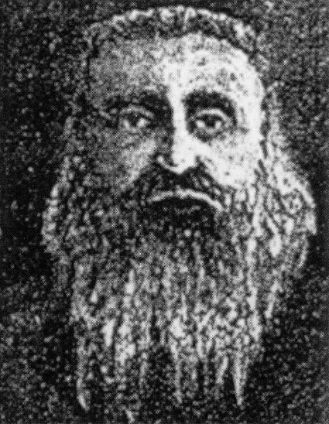
Rabbi Yitzchok of Vorka. Photo by Wikimedia. Translated and adapted from Siach Sarfei Kodesh, vol. 2, p. 117. Reprinted from this week’s website of Chabad.Org
A Bris Milah in
Communist Russia
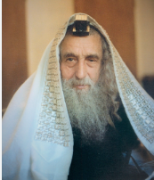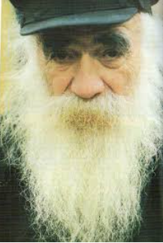
The Ribnitzer Rebbe and Rav Chaim Zanvil Abramowitz of blessed memories
Rav Meilich Biderman related a story. Years ago, in Communist Russia, a Jewish couple was Bentched with a child. The mother wanted her child to have a Bris Milah, but her husband refused because every Jewish ceremony in those days came with a risk of imprisonment. She knew of a day that her husband would be traveling, so she wrote a letter to the Ribnitzer Rebbe, Rav Chaim Zanvil Abramowitz, zt”l, who was known for his Mesiras Nefesh, self-sacrifice, to perform a Bris, and she requested that he come and give her son a Bris.
The Rebbe agreed, and he arrived together with his friend, Rav Mendel Futerfass, zt”l. It was risky to perform the Mitzvah, but they did it with joy. After the Milah, however, there was a complication, and the child began to bleed profusely, and he needed medical care. They couldn’t call a doctor because the doctor would report them to the authorities.
The Ribnitzer Rebbe went into a side room for a short time, and when he came out, Rav Mendel Futerfass exclaimed, “You performed a miracle! The child stopped bleeding! What did you do in there?” The Rebbe replied, “I davened. I said, ‘Ribono Shel Olam! We came here to do a great Mitzvah. Please protect us!’ and Hashem heard my tefilos.”
When Rav Mendel would repeat this story, he would express his great admiration for the Ribnitzer Rebbe’s Emunah. He said, “At that time, I was so afraid that I couldn’t think straight, but the Ribnitzer Rebbe knew that the solution was Tefilah. With his strong Emunah, he saved the child, and also our lives as well!”

Reprinted from the Parshas Re’eh 5784 email of Rabbi Yehuda Winzelberg’s Torah U’Tefillah.

